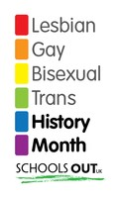
Homework-www.quietkid.com

Design a website, www.quietkid.com. It’s for children who feel isolated for any reason.

Some examples of reasons are…

The child is lesbian, gay, bisexual or trans.

The child has a disability.

The child has to care for a sick or disabled parent.

There are many possibilities. What else can you think of?

Your website needs to find a difficult balance. On the one hand, it should be attractive and interesting, so people use it. On the other hand, children will be coming to the site with serious problems. You need to make sure your site takes these problems seriously.

You should certainly include an emergency number for children in immediate danger.

Think about the good work you’ve just done on understanding people’s different ways of showing their feelings.

Show the children who come to your site you will try to empathise with their problems.

Don’t try to be them, but do try to understand why they have asked you for help.

Don’t make false promises, like claiming everything will be ok. It’s better to be clear you are there for them and will do whatever you can to help.

